**Міністерство освіти і науки України**

**Національний технічний університет України**

**“Київський політехнічний інститут”**

**Факультет прикладної математики**

**Кафедра спеціалізованих комп’ютерних систем**

**Лабораторна робота № 1**

з дисципліни «ВЕБ-дизайн»

«**Розробка статичного інтерфейсу Web-додатка**»



Виконав:

студент групи КВ-83

**Глеб Владислав**

Київ 2021

**Зміст  
Мета**: ознайомитись із засобами мов HTML5 та CSS3 та навчитись застосовувати бібліотеки Twitter Bootstrap/Material UI щодо швидкої побудови Web-інтерфейсу користувача.

**Загальне завдання**: розробити статичні Web-сторінки додатку та перевірити коректне їх відображення на екранах різного розміру.

Інструменти розробки: мови HTML5, CSS3, фреймворки [Twitter Bootstrap](https://getbootstrap.com/) або [Material UI](https://material.io/develop/web) **Зауваження:** програмувати функціональність сайту **не потрібно**(!).

**Завдання**

**Мій Telegram:** @vladyslav_hleb

**Github-репозиторій з лабораторної:** <https://github.com/Vlad492/web-lab1>

**Демо-версія додатка:** <https://vlad492.github.io/web-lab1/>

**Тема: “Телефонний довідник.**   
 У цій лабораторній роботі я розробив статичний Web-інтерфейс для додатку “Телефонний довідник”. Були реалізовані наступні веб-сторінки:

* index.html - головна сторінка.На сторінці можно побачити пости з останніми оновленнями у додатку.
* new-contact.html - сторінка для створення нового контакту. На ній знаходиться звичайна форма з полями, необхідними для створення контакту.
* profile.html - сторінка профілю користувача.
* about.html - сторінка з детальною інформацією про додаток.
* Login/authorization винесені в модальні вікна

**index.html**

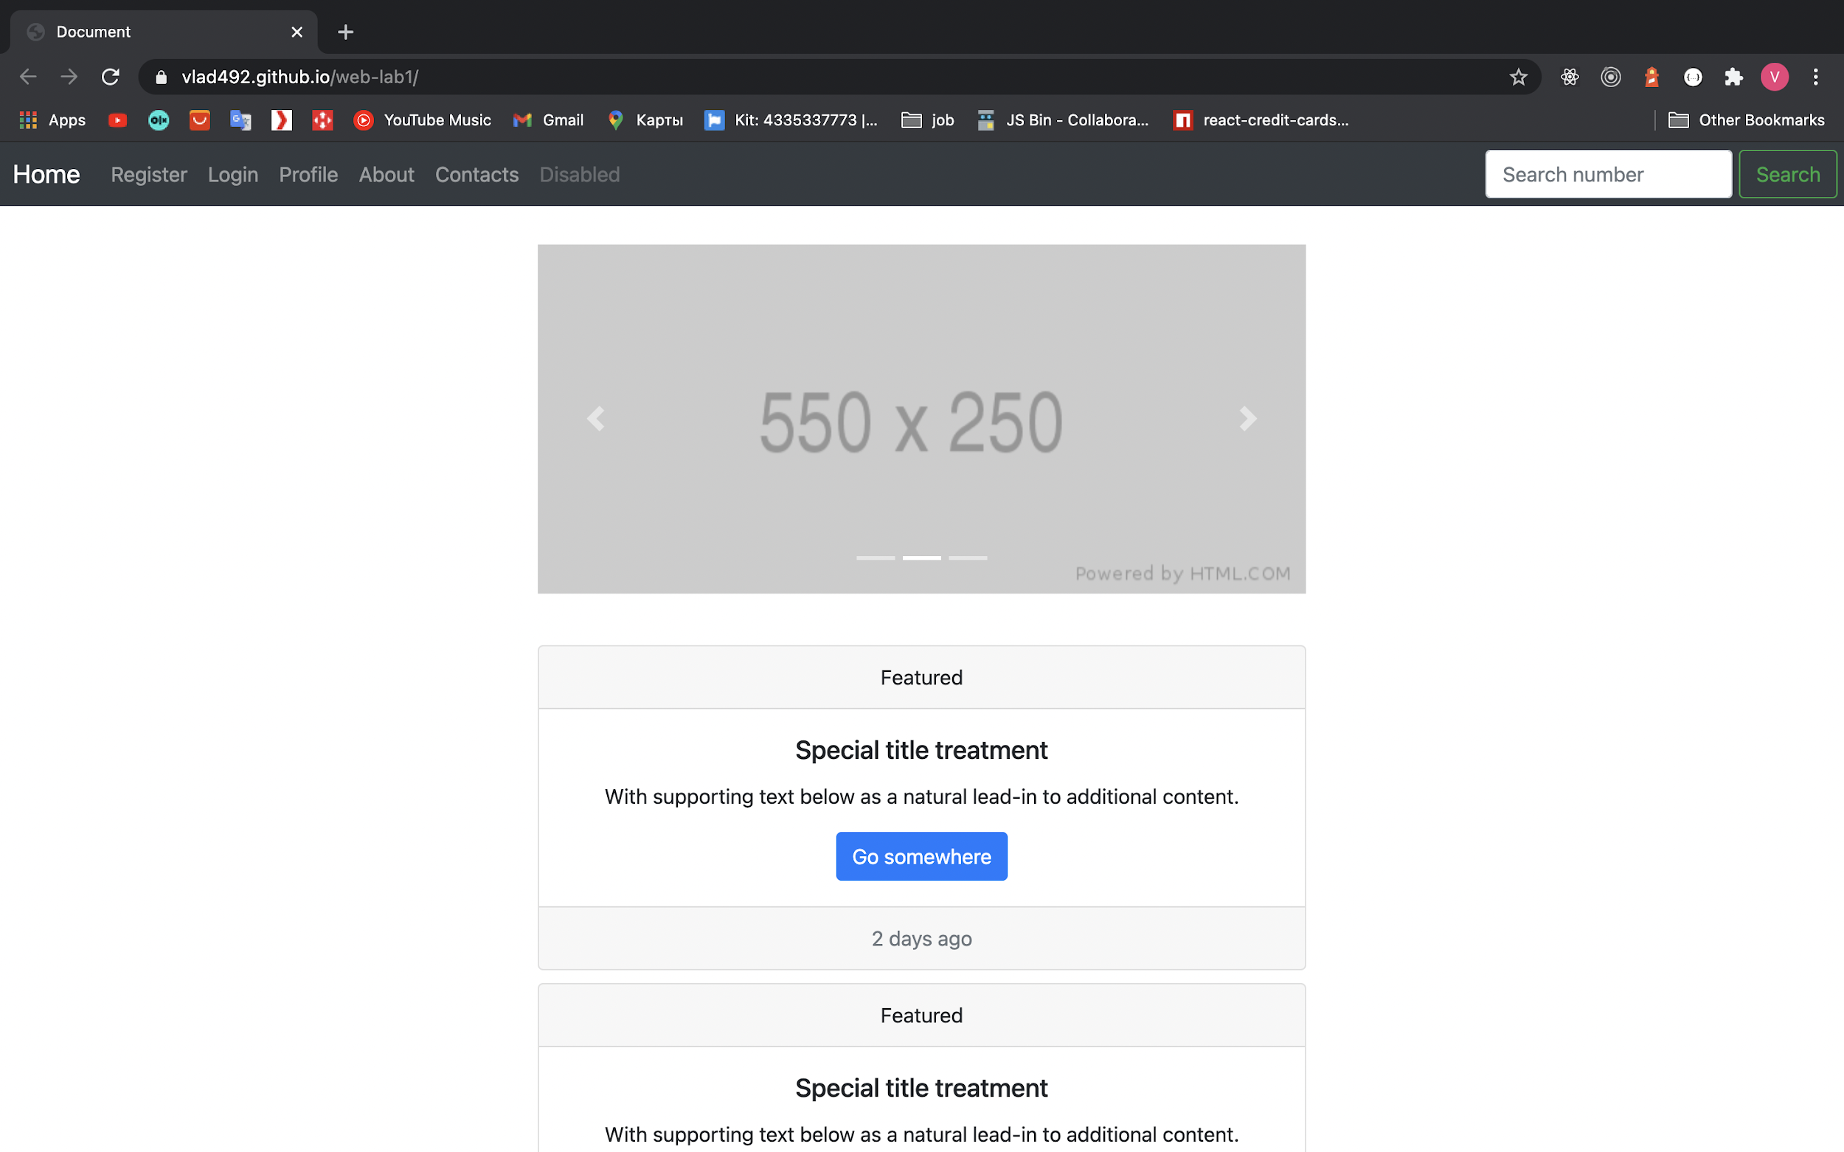

**profile.html**

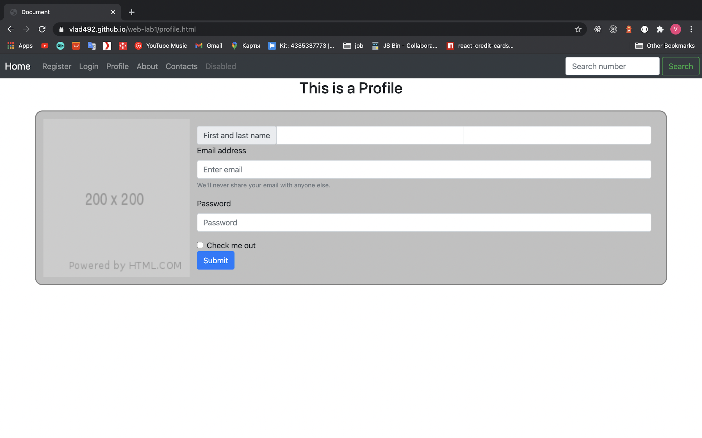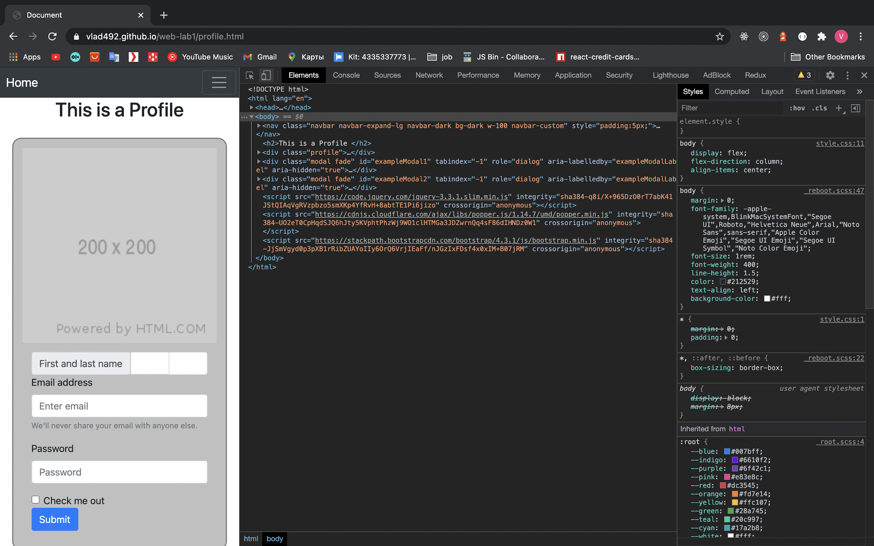

**Login/Register**

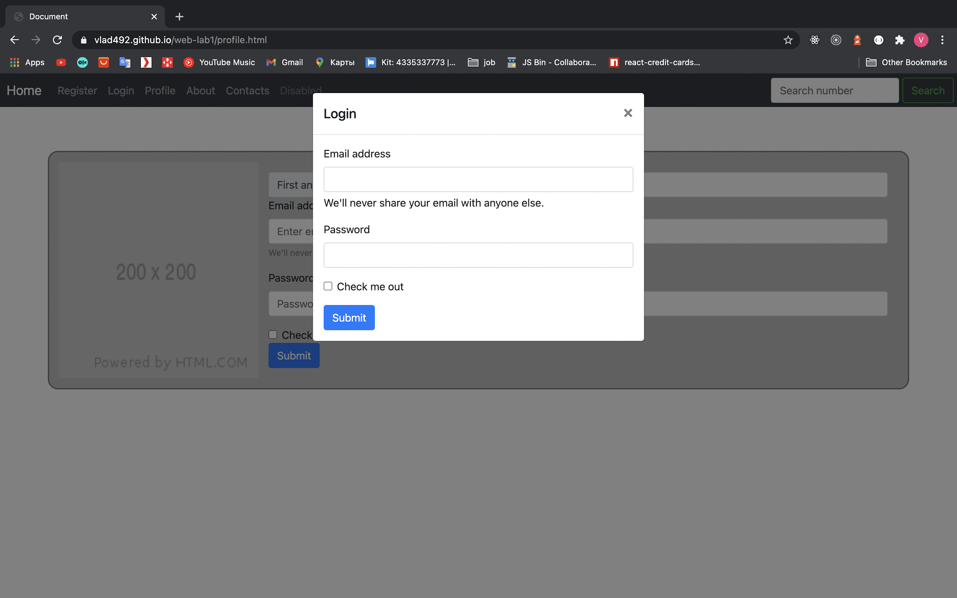

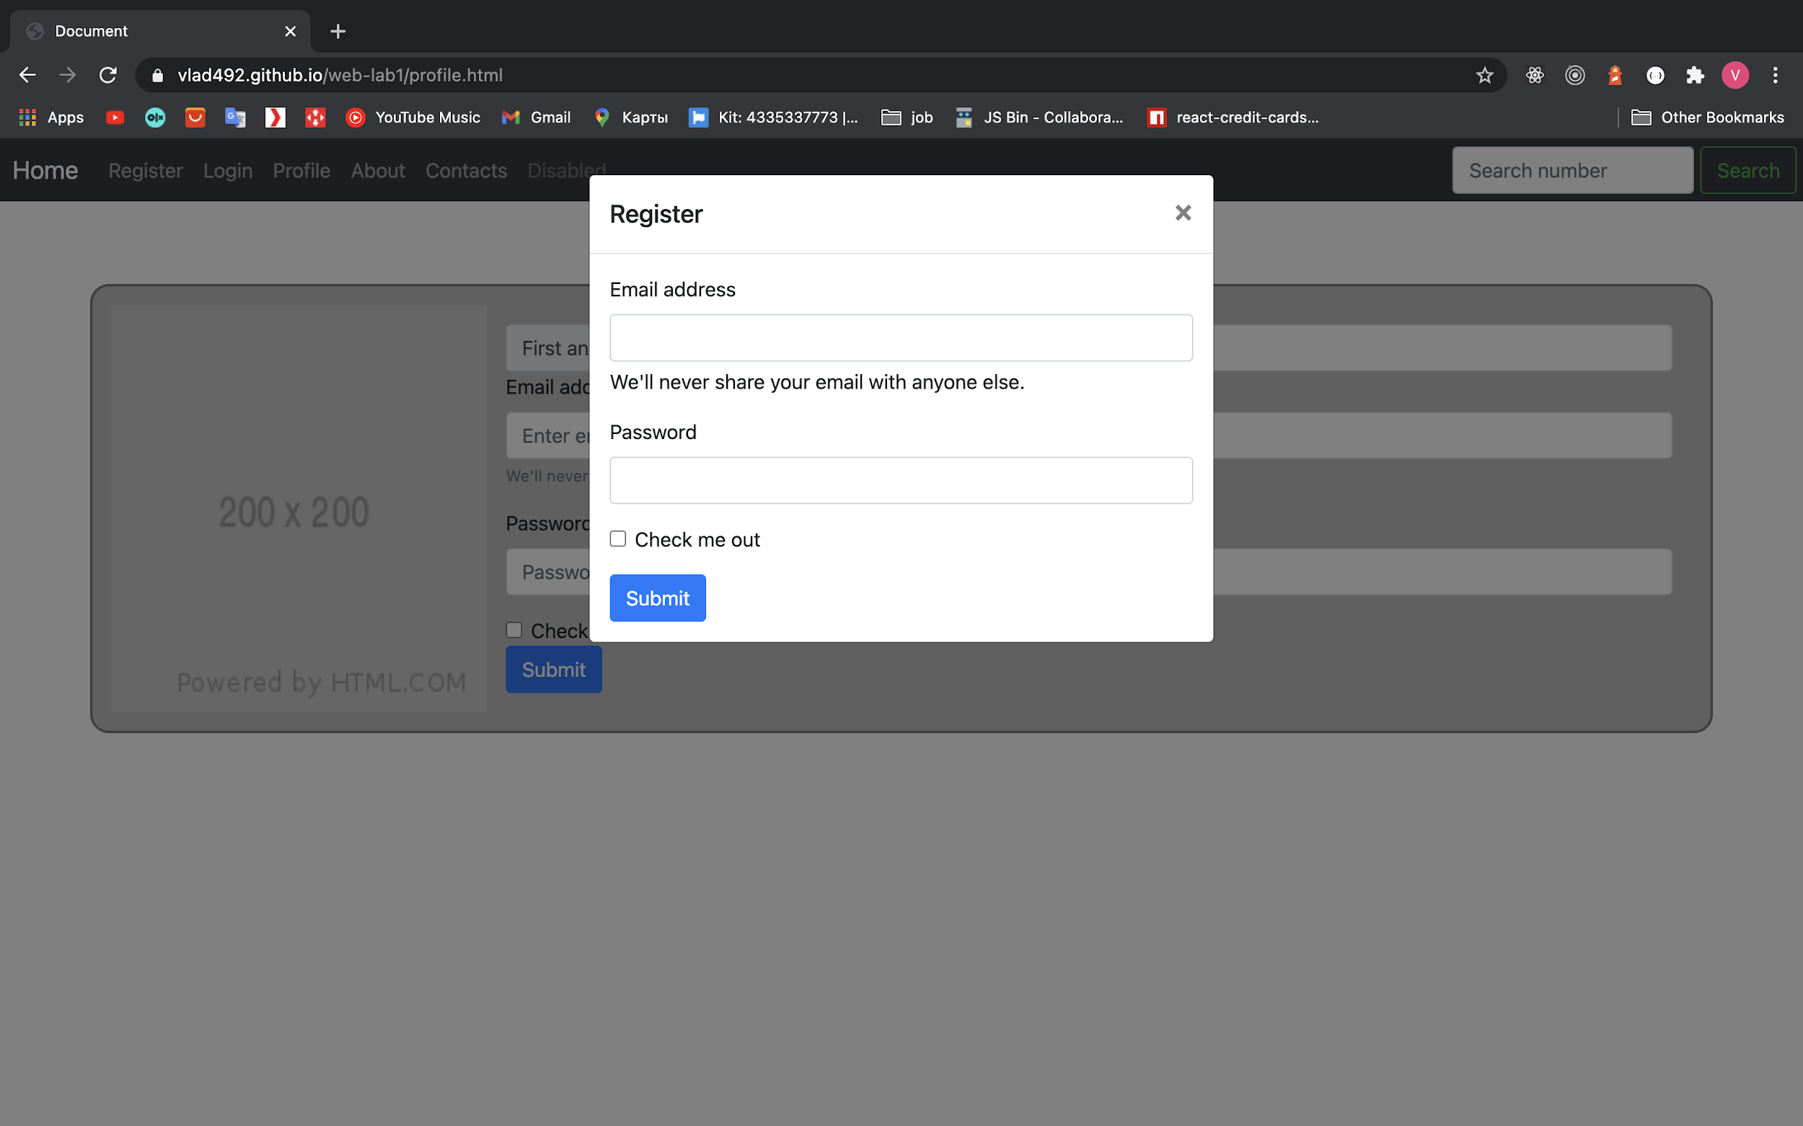

**about.html**

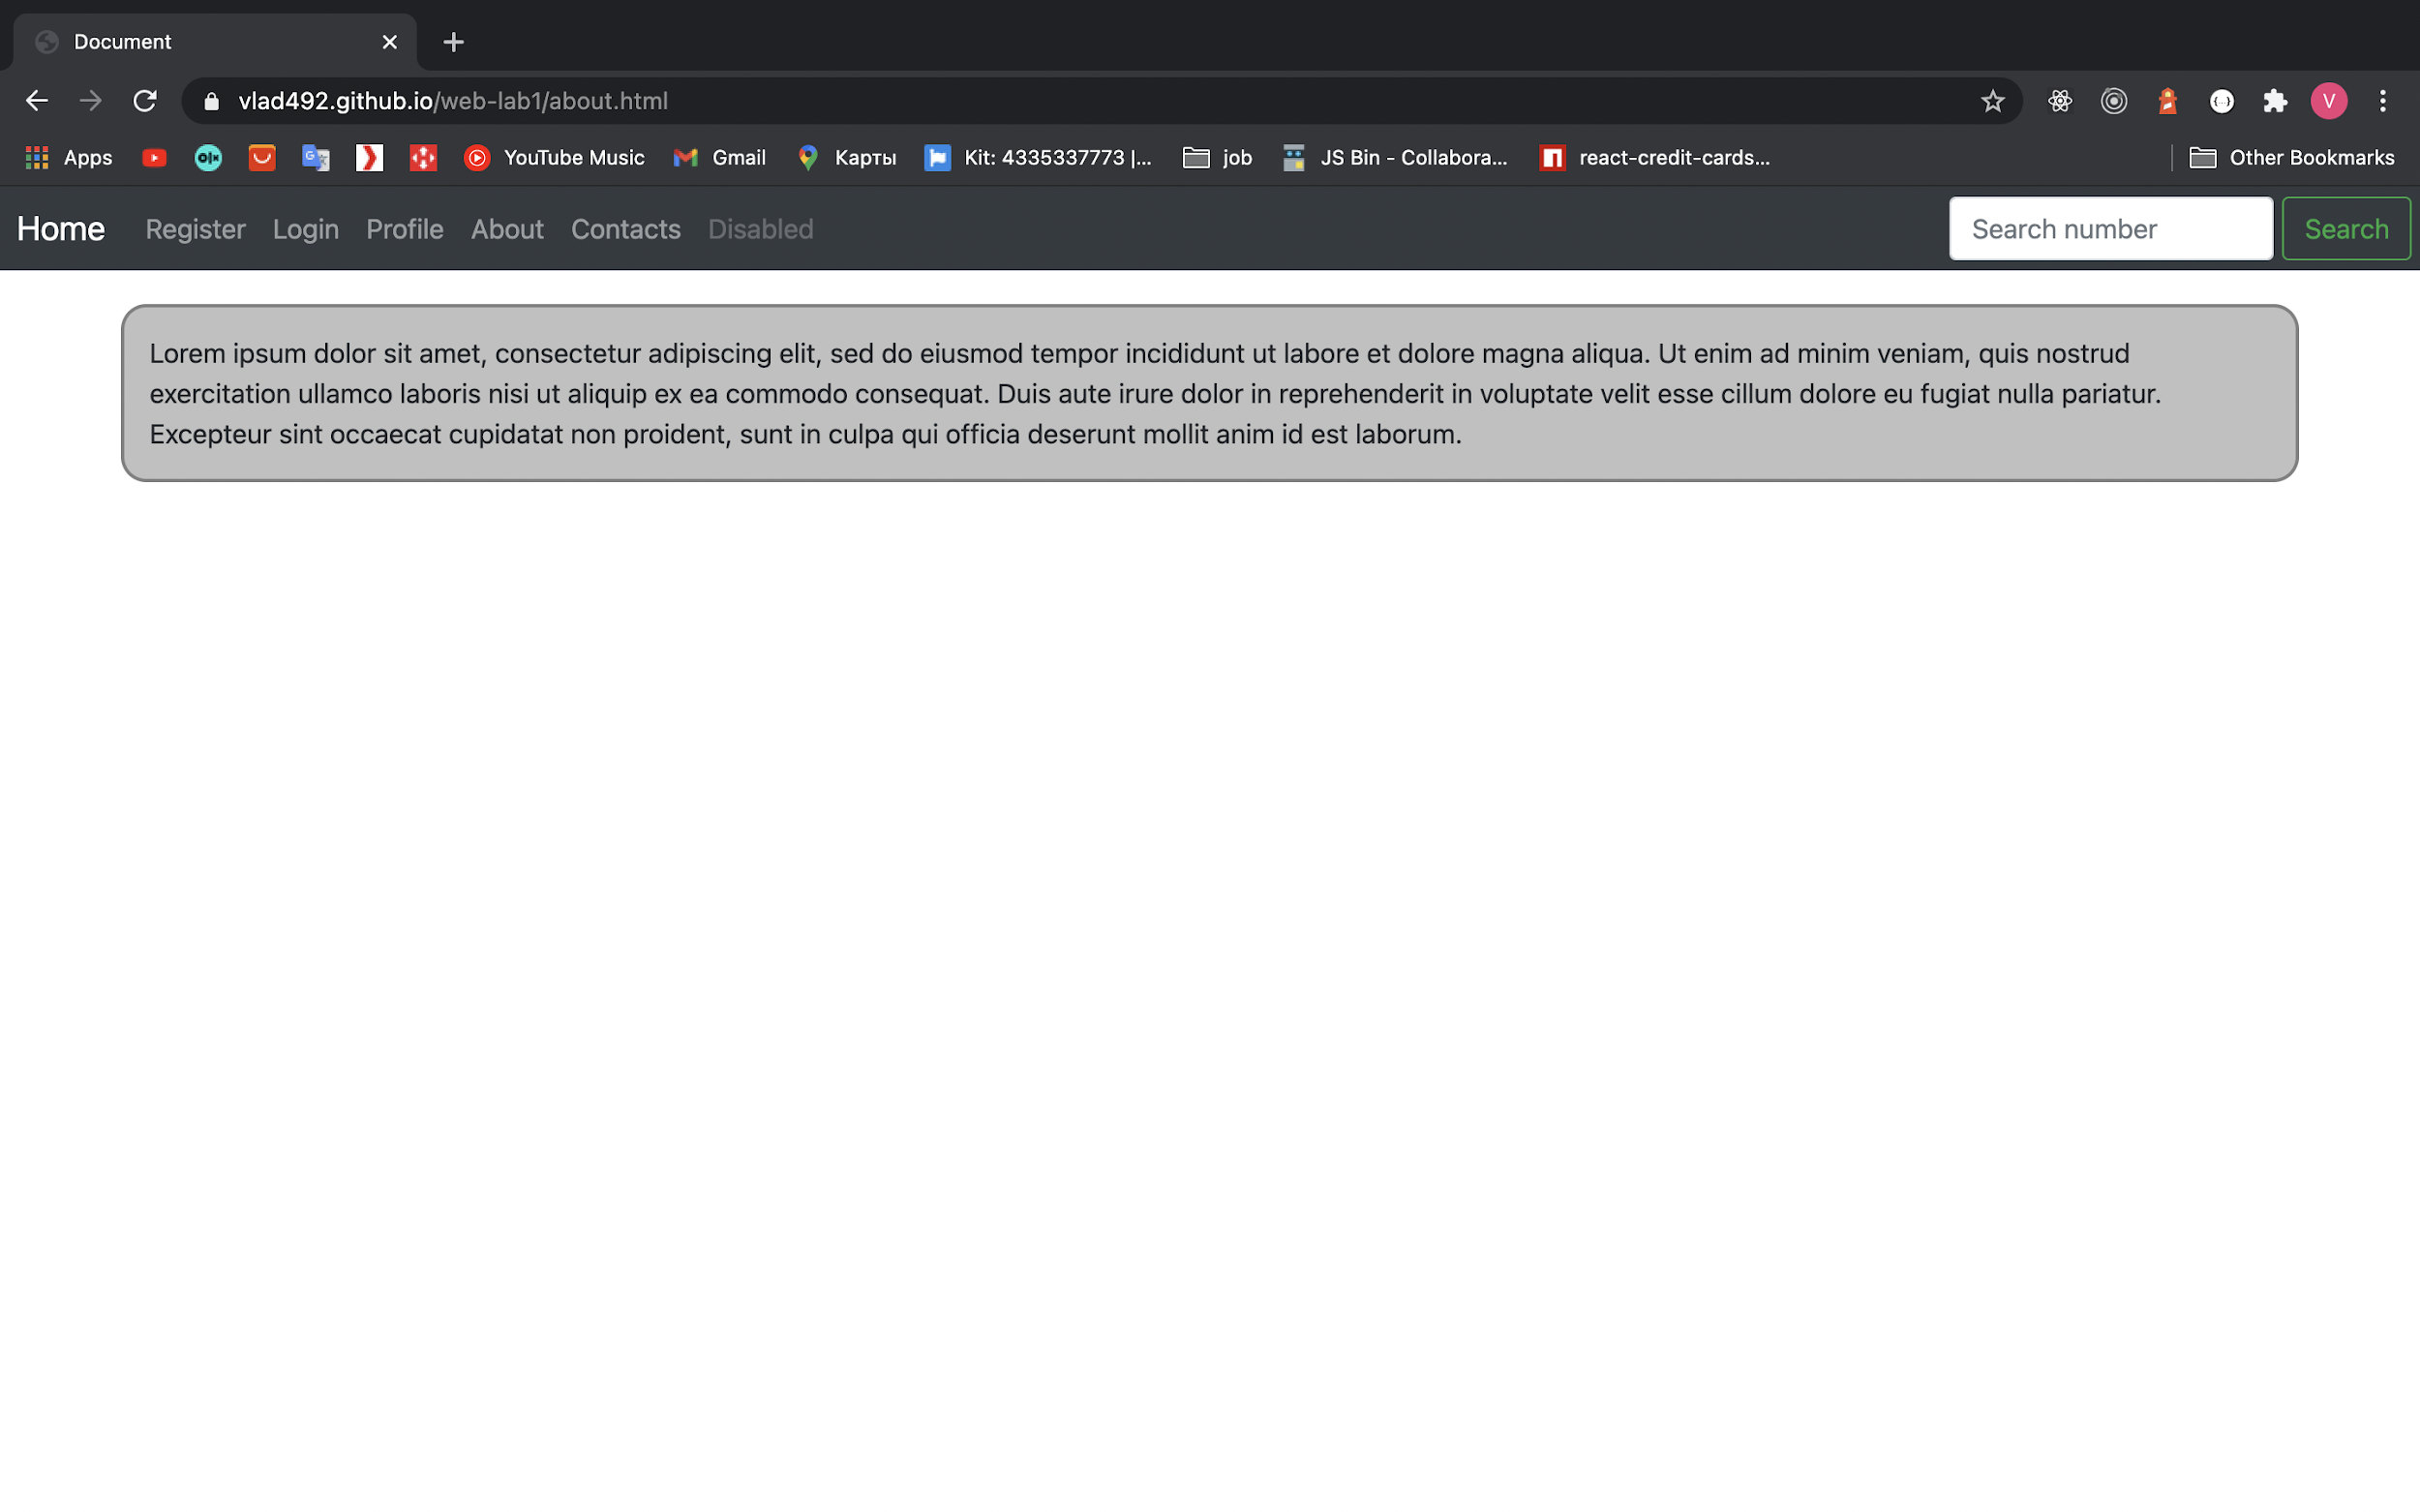

**contacts.html**

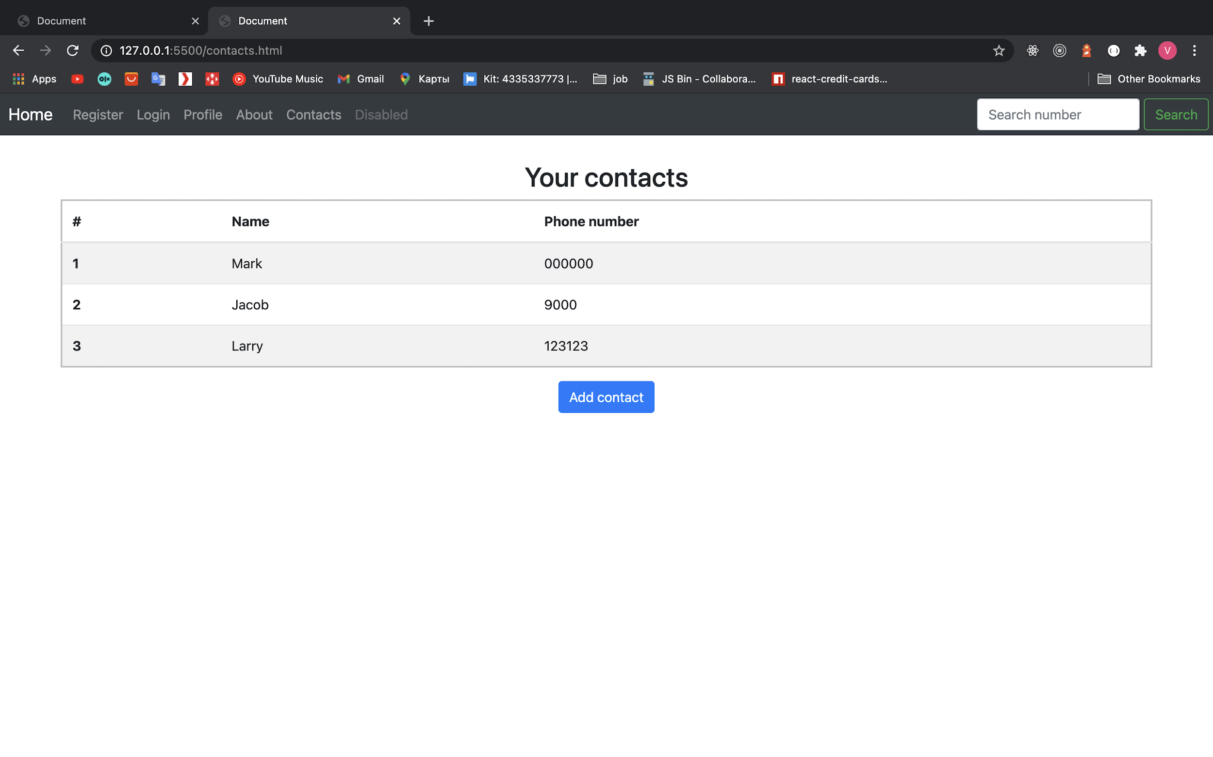

**Mobilе**

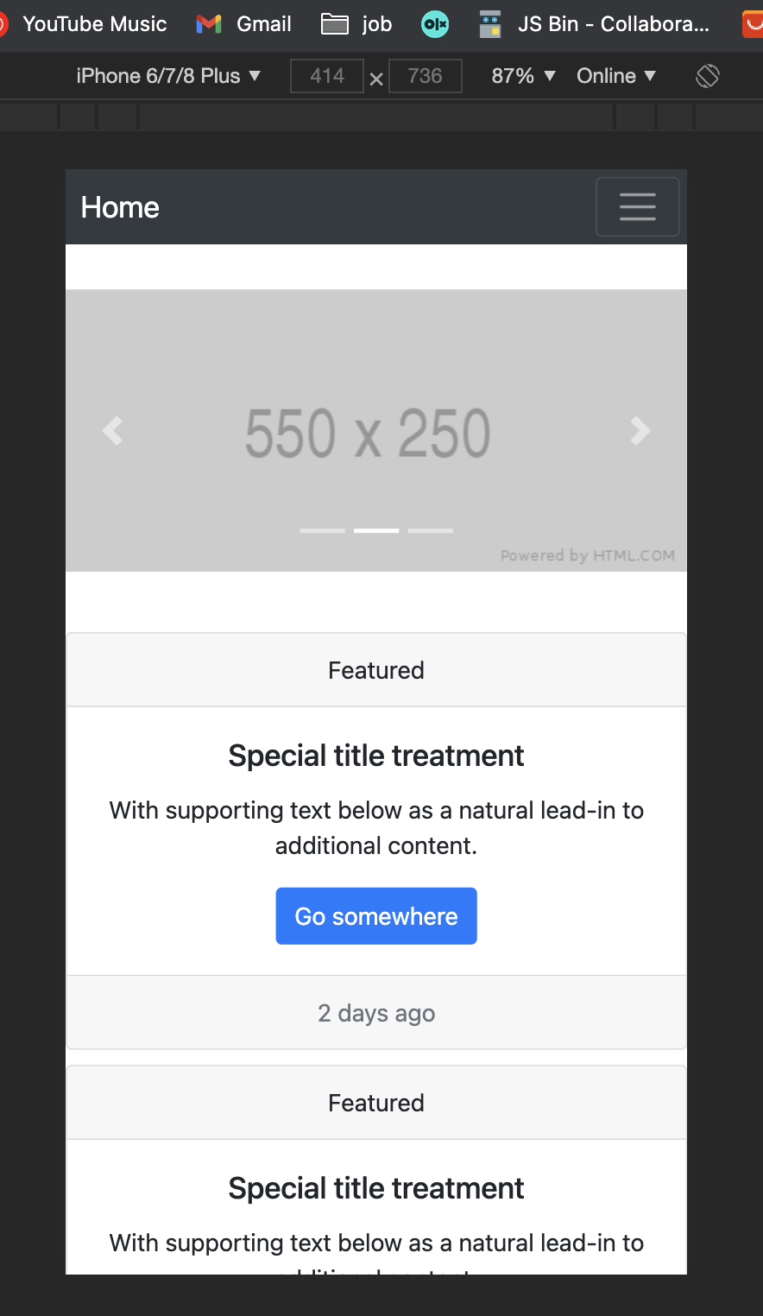

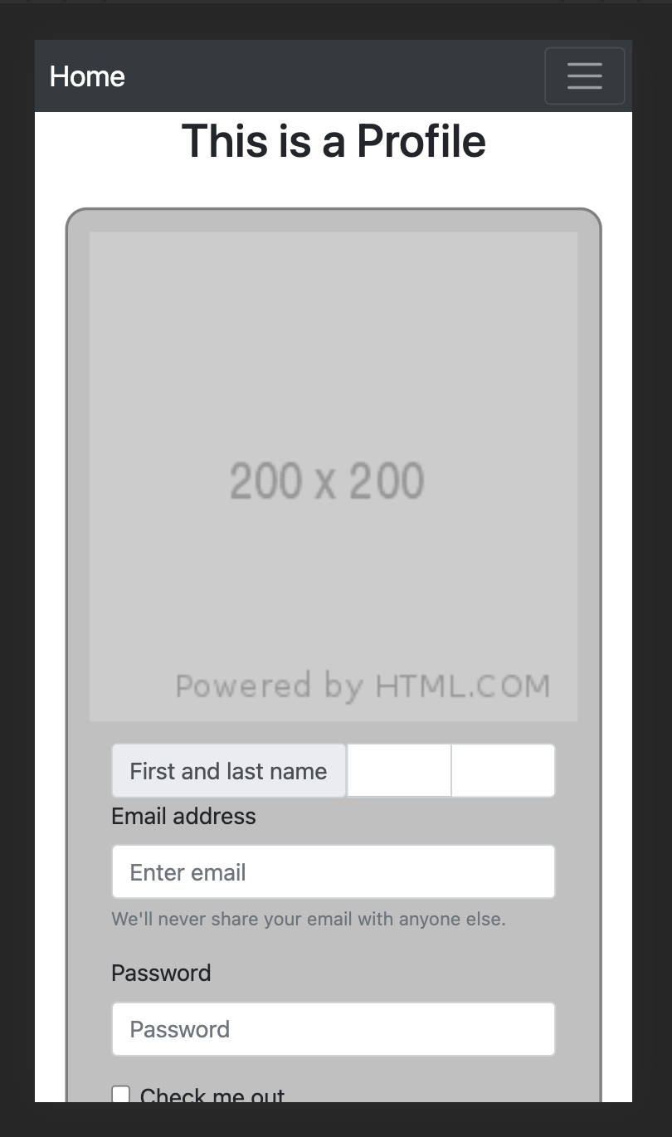

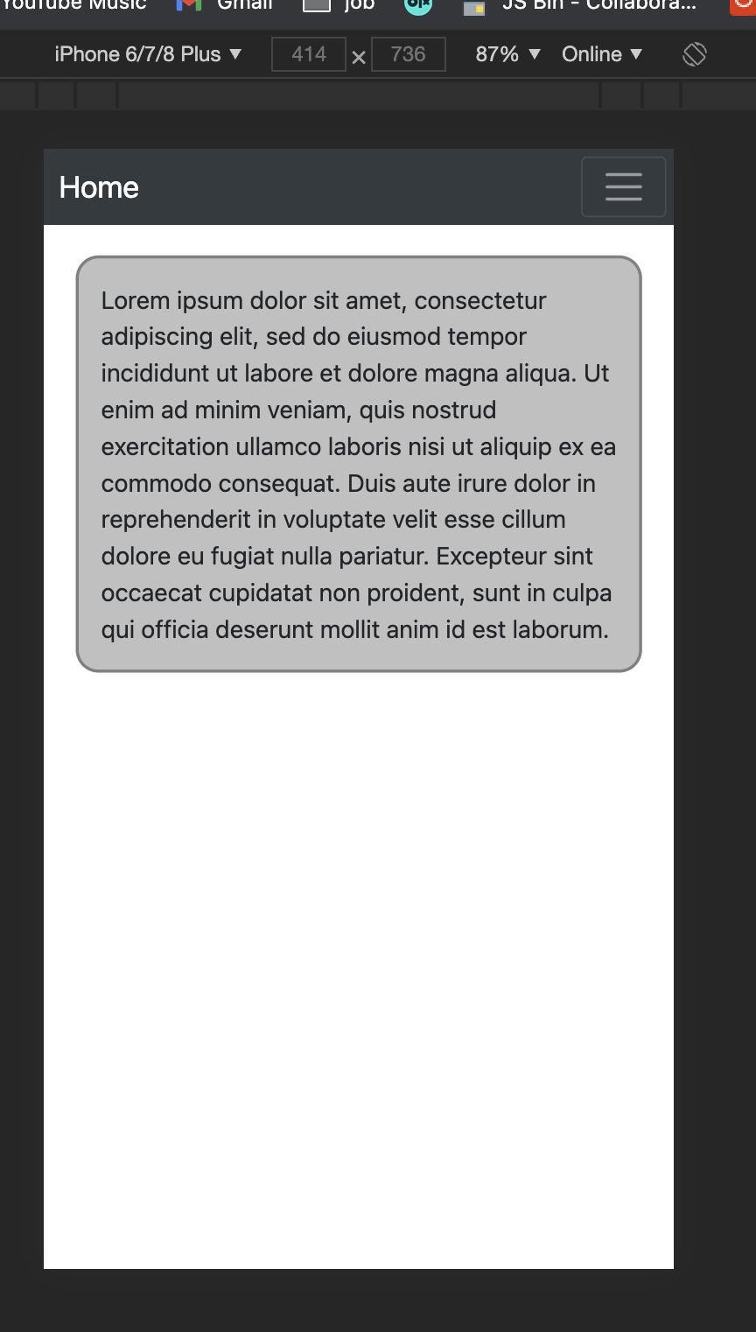

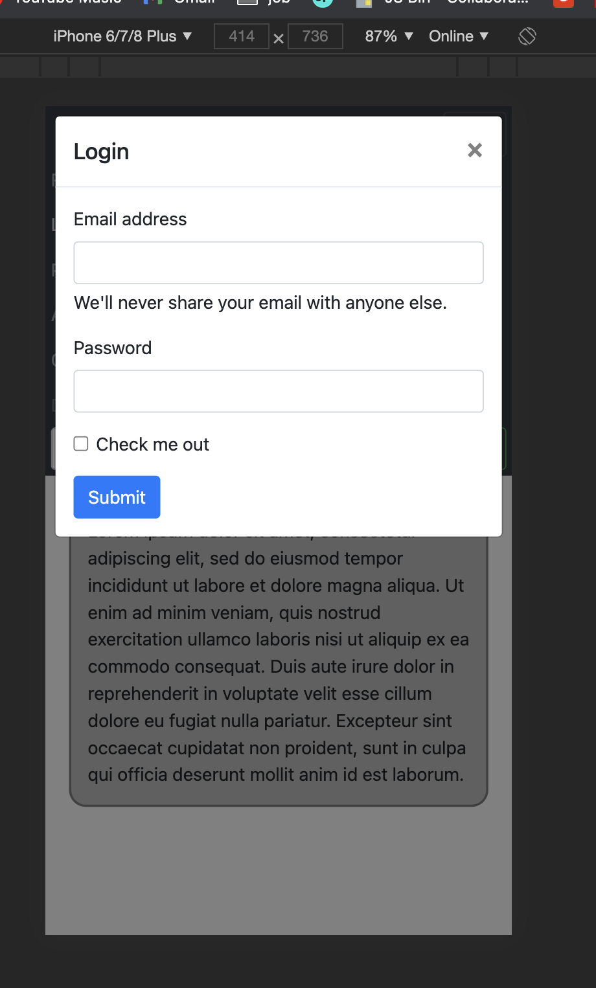

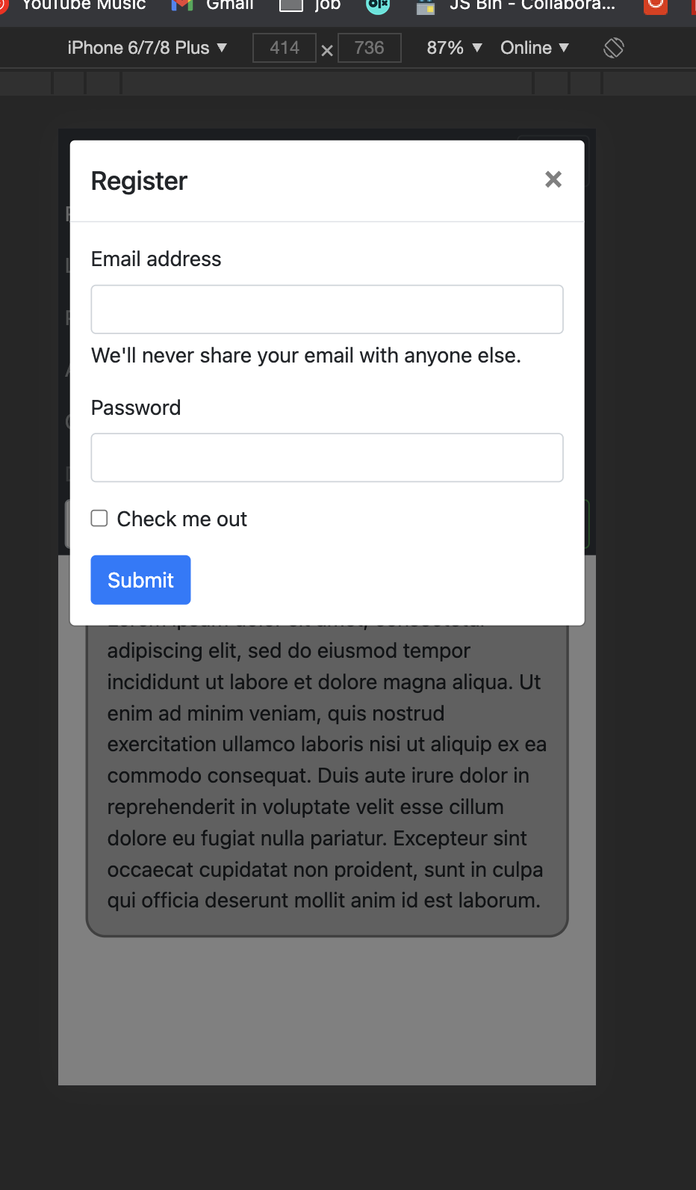

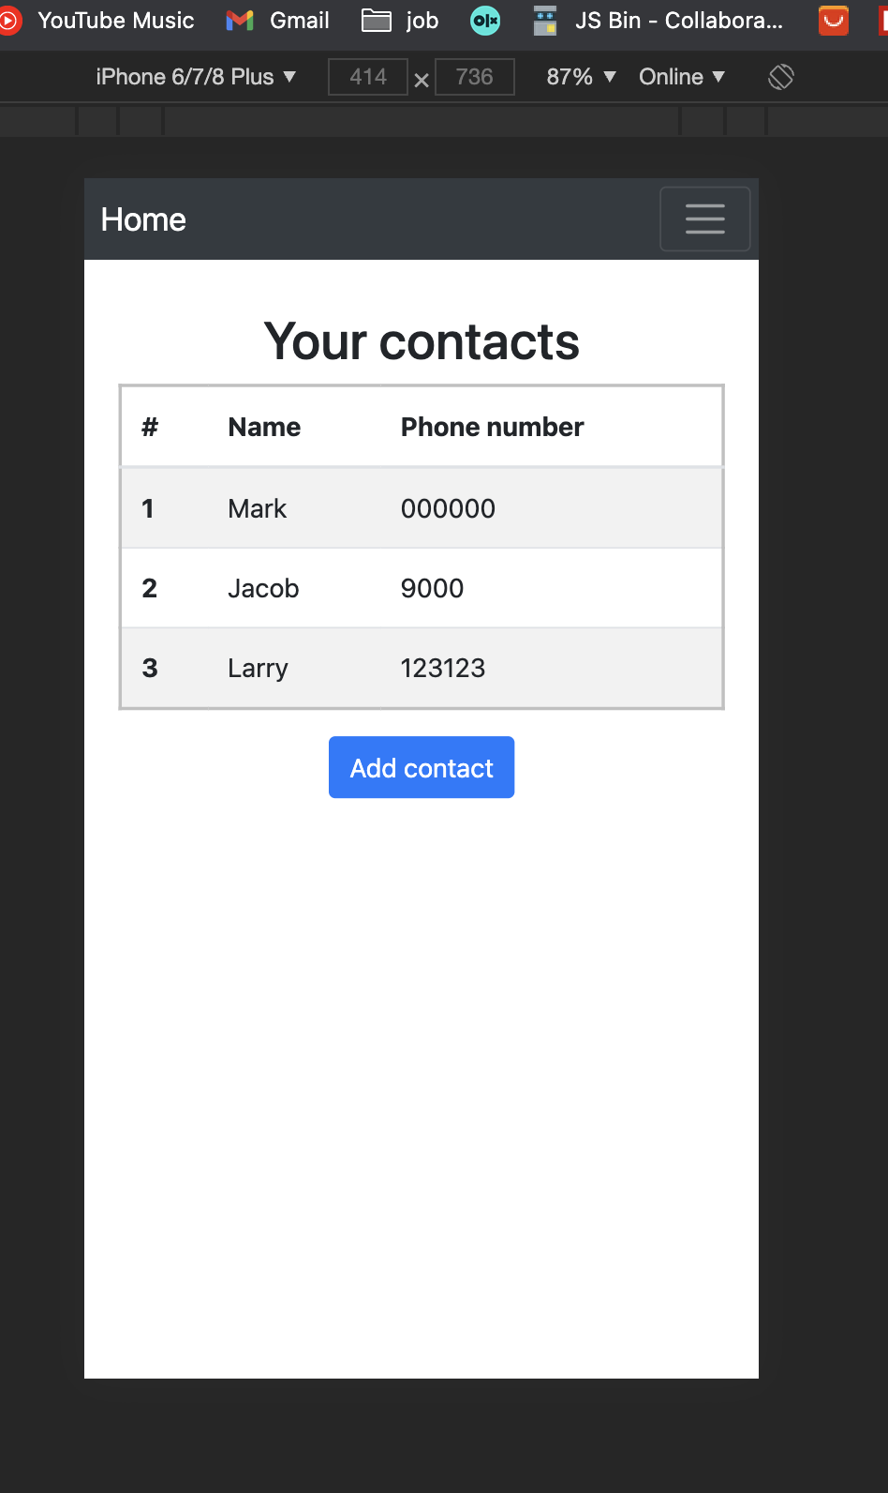

**<!DOCTYPE html>**

**<html lang="en">**

**<head>**

**<meta charset="UTF-8">**

**<meta http-equiv="X-UA-Compatible" content="IE=edge">**

**<meta name="viewport" content="width=device-width, initial-scale=1.0">**

**<title>Document</title>**

**<link rel="stylesheet" href="https://stackpath.bootstrapcdn.com/bootstrap/4.3.1/css/bootstrap.min.css"**

**integrity="sha384-ggOyR0iXCbMQv3Xipma34MD+dH/1fQ784/j6cY/iJTQUOhcWr7x9JvoRxT2MZw1T" crossorigin="anonymous">**

**<link rel="stylesheet" href="css/style.css">**

**</head>**

**<body>**

**<nav class="navbar navbar-expand-lg navbar-dark bg-dark w-100 navbar-custom" style="padding:5px;">**

**<a class="navbar-brand" style="margin-left: 5px;" href="index.html">Home</a>**

**<button class="navbar-toggler" type="button" data-toggle="collapse" data-target="#navbarNav"**

**aria-controls="navbarNav" aria-expanded="false" aria-label="Toggle navigation">**

**<span class="navbar-toggler-icon"></span>**

**</button>**

**<div class="collapse navbar-collapse" style="justify-content: space-between;" id="navbarNav">**

**<ul class="navbar-nav">**

**<li class="nav-item">**

**<a class="nav-link" data-toggle="modal" data-target="#exampleModal2" href="#">Register</a>**

**</li>**

**<li class="nav-item">**

**<a class="nav-link" data-toggle="modal" data-target="#exampleModal1">Login</a>**

**</li>**

**<li class="nav-item">**

**<a class="nav-link" href="profile.html">Profile</a>**

**</li>**

**<li class="nav-item">**

**<a class="nav-link" href="about.html">About</a>**

**</li>**

**<li class="nav-item">**

**<a class="nav-link" href="contacts.html">Contacts</a>**

**</li>**

**<li class="nav-item">**

**<a class="nav-link disabled" href="#">Disabled</a>**

**</li>**

**</ul>**

**<form class="d-flex">**

**<input class="form-control me-2" type="search" placeholder="Search number" aria-label="Search" style="margin-right: 5px;">**

**<button class="btn btn-outline-success" type="submit">Search</button>**

**</form>**

**</div>**

**</nav>**

**<div id="carouselExampleIndicators" class="carousel slide carousel-custom" data-ride="carousel">**

**<ol class="carousel-indicators">**

**<li data-target="#carouselExampleIndicators" data-slide-to="0" class="active"></li>**

**<li data-target="#carouselExampleIndicators" data-slide-to="1"></li>**

**<li data-target="#carouselExampleIndicators" data-slide-to="2"></li>**

**</ol>**

**<div class="carousel-inner">**

**<div class="carousel-item active">**

**<img class="d-block w-100" src="https://via.placeholder.com/550x250" alt="First slide">**

**</div>**

**<div class="carousel-item">**

**<img class="d-block w-100" src="https://via.placeholder.com/550x250" alt="Second slide">**

**</div>**

**<div class="carousel-item">**

**<img class="d-block w-100" src="https://via.placeholder.com/550x250" alt="Third slide">**

**</div>**

**</div>**

**<a class="carousel-control-prev" href="#carouselExampleIndicators" role="button" data-slide="prev">**

**<span class="carousel-control-prev-icon" aria-hidden="true"></span>**

**<span class="sr-only">Previous</span>**

**</a>**

**<a class="carousel-control-next" href="#carouselExampleIndicators" role="button" data-slide="next">**

**<span class="carousel-control-next-icon" aria-hidden="true"></span>**

**<span class="sr-only">Next</span>**

**</a>**

**</div>**

**<div class="modal fade" id="exampleModal1" tabindex="-1" role="dialog" aria-labelledby="exampleModalLabel"**

**aria-hidden="true">**

**<div class="modal-dialog" role="document">**

**<div class="modal-content">**

**<div class="modal-header">**

**<h5 class="modal-title" id="exampleModalLabel">Login</h5>**

**<button type="button" class="close" data-dismiss="modal" aria-label="Close">**

**<span aria-hidden="true">&times;</span>**

**</button>**

**</div>**

**<div class="modal-body">**

**<form>**

**<div class="mb-3">**

**<label for="exampleInputEmail1" class="form-label">Email address</label>**

**<input type="email" class="form-control" id="exampleInputEmail1" aria-describedby="emailHelp">**

**<div id="emailHelp" class="form-text">We'll never share your email with anyone else.</div>**

**</div>**

**<div class="mb-3">**

**<label for="exampleInputPassword1" class="form-label">Password</label>**

**<input type="password" class="form-control" id="exampleInputPassword1">**

**</div>**

**<div class="mb-3 form-check">**

**<input type="checkbox" class="form-check-input" id="exampleCheck1">**

**<label class="form-check-label" for="exampleCheck1">Check me out</label>**

**</div>**

**<button type="submit" class="btn btn-primary" data-dismiss="modal">Submit</button>**

**</form>**

**</div>**

**</div>**

**</div>**

**</div>**

**<div class="modal fade" id="exampleModal2" tabindex="-1" role="dialog" aria-labelledby="exampleModalLabel"**

**aria-hidden="true">**

**<div class="modal-dialog" role="document">**

**<div class="modal-content">**

**<div class="modal-header">**

**<h5 class="modal-title" id="exampleModalLabel">Register</h5>**

**<button type="button" class="close" data-dismiss="modal" aria-label="Close">**

**<span aria-hidden="true">&times;</span>**

**</button>**

**</div>**

**<div class="modal-body">**

**<form>**

**<div class="mb-3">**

**<label for="exampleInputEmail1" class="form-label">Email address</label>**

**<input type="email" class="form-control" id="exampleInputEmail1" aria-describedby="emailHelp">**

**<div id="emailHelp" class="form-text">We'll never share your email with anyone else.</div>**

**</div>**

**<div class="mb-3">**

**<label for="exampleInputPassword1" class="form-label">Password</label>**

**<input type="password" class="form-control" id="exampleInputPassword1">**

**</div>**

**<div class="mb-3 form-check">**

**<input type="checkbox" class="form-check-input" id="exampleCheck1">**

**<label class="form-check-label" for="exampleCheck1">Check me out</label>**

**</div>**

**<button type="submit" class="btn btn-primary" data-dismiss="modal">Submit</button>**

**</form>**

**</div>**

**</div>**

**</div>**

**</div>**

**<div class="cards">**

**<div class="card text-center">**

**<div class="card-header">**

**Featured**

**</div>**

**<div class="card-body">**

**<h5 class="card-title">Special title treatment</h5>**

**<p class="card-text">With supporting text below as a natural lead-in to additional content.</p>**

**<a href="#" class="btn btn-primary">Go somewhere</a>**

**</div>**

**<div class="card-footer text-muted">**

**2 days ago**

**</div>**

**</div>**

**<div class="card text-center">**

**<div class="card-header">**

**Featured**

**</div>**

**<div class="card-body">**

**<h5 class="card-title">Special title treatment</h5>**

**<p class="card-text">With supporting text below as a natural lead-in to additional content.</p>**

**<a href="#" class="btn btn-primary">Go somewhere</a>**

**</div>**

**<div class="card-footer text-muted">**

**2 days ago**

**</div>**

**</div>**

**<div class="card text-center">**

**<div class="card-header">**

**Featured**

**</div>**

**<div class="card-body">**

**<h5 class="card-title">Special title treatment</h5>**

**<p class="card-text">With supporting text below as a natural lead-in to additional content.</p>**

**<a href="#" class="btn btn-primary">Go somewhere</a>**

**</div>**

**<div class="card-footer text-muted">**

**2 days ago**

**</div>**

**</div>**

**</div>**

**<script src="https://code.jquery.com/jquery-3.3.1.slim.min.js"**

**integrity="sha384-q8i/X+965DzO0rT7abK41JStQIAqVgRVzpbzo5smXKp4YfRvH+8abtTE1Pi6jizo"**

**crossorigin="anonymous"></script>**

**<script src="https://cdnjs.cloudflare.com/ajax/libs/popper.js/1.14.7/umd/popper.min.js"**

**integrity="sha384-UO2eT0CpHqdSJQ6hJty5KVphtPhzWj9WO1clHTMGa3JDZwrnQq4sF86dIHNDz0W1"**

**crossorigin="anonymous"></script>**

**<script src="https://stackpath.bootstrapcdn.com/bootstrap/4.3.1/js/bootstrap.min.js"**

**integrity="sha384-JjSmVgyd0p3pXB1rRibZUAYoIIy6OrQ6VrjIEaFf/nJGzIxFDsf4x0xIM+B07jRM"**

**crossorigin="anonymous"></script>**

**</body>**

**</html>**

**contacts.html**

**<!DOCTYPE html>**

**<html lang="en">**

**<head>**

**<meta charset="UTF-8">**

**<meta http-equiv="X-UA-Compatible" content="IE=edge">**

**<meta name="viewport" content="width=device-width, initial-scale=1.0">**

**<title>Document</title>**

**<link rel="stylesheet" href="https://stackpath.bootstrapcdn.com/bootstrap/4.3.1/css/bootstrap.min.css"**

**integrity="sha384-ggOyR0iXCbMQv3Xipma34MD+dH/1fQ784/j6cY/iJTQUOhcWr7x9JvoRxT2MZw1T" crossorigin="anonymous">**

**<link rel="stylesheet" href="css/style.css">**

**</head>**

**<body>**

**<nav class="navbar navbar-expand-lg navbar-dark bg-dark w-100 navbar-custom" style="padding:5px;">**

**<a class="navbar-brand" style="margin-left: 5px;" href="index.html">Home</a>**

**<button class="navbar-toggler" type="button" data-toggle="collapse" data-target="#navbarNav"**

**aria-controls="navbarNav" aria-expanded="false" aria-label="Toggle navigation">**

**<span class="navbar-toggler-icon"></span>**

**</button>**

**<div class="collapse navbar-collapse" style="justify-content: space-between;" id="navbarNav">**

**<ul class="navbar-nav">**

**<li class="nav-item">**

**<a class="nav-link" data-toggle="modal" data-target="#exampleModal2" href="#">Register</a>**

**</li>**

**<li class="nav-item">**

**<a class="nav-link" data-toggle="modal" data-target="#exampleModal1">Login</a>**

**</li>**

**<li class="nav-item">**

**<a class="nav-link" href="profile.html">Profile</a>**

**</li>**

**<li class="nav-item">**

**<a class="nav-link" href="about.html">About</a>**

**</li>**

**<li class="nav-item">**

**<a class="nav-link" href="contacts.html">Contacts</a>**

**</li>**

**<li class="nav-item">**

**<a class="nav-link disabled" href="#">Disabled</a>**

**</li>**

**</ul>**

**<form class="d-flex">**

**<input class="form-control me-2" type="search" placeholder="Search number" aria-label="Search" style="margin-right: 5px;">**

**<button class="btn btn-outline-success" type="submit">Search</button>**

**</form>**

**</div>**

**</nav>**

**<h2 style="margin-top: 30px;">Your contacts</h2>**

**<table class="table table-striped contacts">**

**<thead>**

**<tr>**

**<th scope="col">#</th>**

**<th scope="col">Name</th>**

**<th scope="col">Phone number</th>**

**</tr>**

**</thead>**

**<tbody>**

**<tr>**

**<th scope="row">1</th>**

**<td>Mark</td>**

**<td>000000</td>**

**</tr>**

**<tr>**

**<th scope="row">2</th>**

**<td>Jacob</td>**

**<td>9000</td>**

**</tr>**

**<tr>**

**<th scope="row">3</th>**

**<td>Larry</td>**

**<td>123123</td>**

**</tr>**

**</tbody>**

**</table>**

**<button class="btn btn-primary">Add contact</button>**

**<div class="modal fade" id="exampleModal1" tabindex="-1" role="dialog" aria-labelledby="exampleModalLabel"**

**aria-hidden="true">**

**<div class="modal-dialog" role="document">**

**<div class="modal-content">**

**<div class="modal-header">**

**<h5 class="modal-title" id="exampleModalLabel">Login</h5>**

**<button type="button" class="close" data-dismiss="modal" aria-label="Close">**

**<span aria-hidden="true">&times;</span>**

**</button>**

**</div>**

**<div class="modal-body">**

**<form>**

**<div class="mb-3">**

**<label for="exampleInputEmail1" class="form-label">Email address</label>**

**<input type="email" class="form-control" id="exampleInputEmail1" aria-describedby="emailHelp">**

**<div id="emailHelp" class="form-text">We'll never share your email with anyone else.</div>**

**</div>**

**<div class="mb-3">**

**<label for="exampleInputPassword1" class="form-label">Password</label>**

**<input type="password" class="form-control" id="exampleInputPassword1">**

**</div>**

**<div class="mb-3 form-check">**

**<input type="checkbox" class="form-check-input" id="exampleCheck1">**

**<label class="form-check-label" for="exampleCheck1">Check me out</label>**

**</div>**

**<button type="submit" class="btn btn-primary" data-dismiss="modal">Submit</button>**

**</form>**

**</div>**

**</div>**

**</div>**

**</div>**

**<div class="modal fade" id="exampleModal2" tabindex="-1" role="dialog" aria-labelledby="exampleModalLabel"**

**aria-hidden="true">**

**<div class="modal-dialog" role="document">**

**<div class="modal-content">**

**<div class="modal-header">**

**<h5 class="modal-title" id="exampleModalLabel">Register</h5>**

**<button type="button" class="close" data-dismiss="modal" aria-label="Close">**

**<span aria-hidden="true">&times;</span>**

**</button>**

**</div>**

**<div class="modal-body">**

**<form>**

**<div class="mb-3">**

**<label for="exampleInputEmail1" class="form-label">Email address</label>**

**<input type="email" class="form-control" id="exampleInputEmail1" aria-describedby="emailHelp">**

**<div id="emailHelp" class="form-text">We'll never share your email with anyone else.</div>**

**</div>**

**<div class="mb-3">**

**<label for="exampleInputPassword1" class="form-label">Password</label>**

**<input type="password" class="form-control" id="exampleInputPassword1">**

**</div>**

**<div class="mb-3 form-check">**

**<input type="checkbox" class="form-check-input" id="exampleCheck1">**

**<label class="form-check-label" for="exampleCheck1">Check me out</label>**

**</div>**

**<button type="submit" class="btn btn-primary" data-dismiss="modal">Submit</button>**

**</form>**

**</div>**

**</div>**

**</div>**

**</div>**

**<script src="https://code.jquery.com/jquery-3.3.1.slim.min.js"**

**integrity="sha384-q8i/X+965DzO0rT7abK41JStQIAqVgRVzpbzo5smXKp4YfRvH+8abtTE1Pi6jizo"**

**crossorigin="anonymous"></script>**

**<script src="https://cdnjs.cloudflare.com/ajax/libs/popper.js/1.14.7/umd/popper.min.js"**

**integrity="sha384-UO2eT0CpHqdSJQ6hJty5KVphtPhzWj9WO1clHTMGa3JDZwrnQq4sF86dIHNDz0W1"**

**crossorigin="anonymous"></script>**

**<script src="https://stackpath.bootstrapcdn.com/bootstrap/4.3.1/js/bootstrap.min.js"**

**integrity="sha384-JjSmVgyd0p3pXB1rRibZUAYoIIy6OrQ6VrjIEaFf/nJGzIxFDsf4x0xIM+B07jRM"**

**crossorigin="anonymous"></script>**

**</body>**

**</html>**

**about.html**

**<!DOCTYPE html>**

**<html lang="en">**

**<head>**

**<meta charset="UTF-8">**

**<meta http-equiv="X-UA-Compatible" content="IE=edge">**

**<meta name="viewport" content="width=device-width, initial-scale=1.0">**

**<title>Document</title>**

**<link rel="stylesheet" href="https://stackpath.bootstrapcdn.com/bootstrap/4.3.1/css/bootstrap.min.css"**

**integrity="sha384-ggOyR0iXCbMQv3Xipma34MD+dH/1fQ784/j6cY/iJTQUOhcWr7x9JvoRxT2MZw1T" crossorigin="anonymous">**

**<link rel="stylesheet" href="css/style.css">**

**</head>**

**<body>**

**<nav class="navbar navbar-expand-lg navbar-dark bg-dark w-100 navbar-custom" style="padding:5px;">**

**<a class="navbar-brand" style="margin-left: 5px;" href="index.html">Home</a>**

**<button class="navbar-toggler" type="button" data-toggle="collapse" data-target="#navbarNav"**

**aria-controls="navbarNav" aria-expanded="false" aria-label="Toggle navigation">**

**<span class="navbar-toggler-icon"></span>**

**</button>**

**<div class="collapse navbar-collapse" style="justify-content: space-between;" id="navbarNav">**

**<ul class="navbar-nav">**

**<li class="nav-item">**

**<a class="nav-link" data-toggle="modal" data-target="#exampleModal2" href="#">Register</a>**

**</li>**

**<li class="nav-item">**

**<a class="nav-link" data-toggle="modal" data-target="#exampleModal1">Login</a>**

**</li>**

**<li class="nav-item">**

**<a class="nav-link" href="profile.html">Profile</a>**

**</li>**

**<li class="nav-item">**

**<a class="nav-link" href="about.html">About</a>**

**</li>**

**<li class="nav-item">**

**<a class="nav-link" href="contacts.html">Contacts</a>**

**</li>**

**<li class="nav-item">**

**<a class="nav-link disabled" href="#">Disabled</a>**

**</li>**

**</ul>**

**<form class="d-flex">**

**<input class="form-control me-2" type="search" placeholder="Search number" aria-label="Search"**

**style="margin-right: 5px;">**

**<button class="btn btn-outline-success" type="submit">Search</button>**

**</form>**

**</div>**

**</nav>**

**<div class="about">Lorem ipsum dolor sit amet, consectetur adipiscing elit, sed do eiusmod tempor incididunt ut labore et dolore magna aliqua. Ut enim ad minim veniam, quis nostrud exercitation ullamco laboris nisi ut aliquip ex ea commodo consequat. Duis aute irure dolor in reprehenderit in voluptate velit esse cillum dolore eu fugiat nulla pariatur. Excepteur sint occaecat cupidatat non proident, sunt in culpa qui officia deserunt mollit anim id est laborum. </div>**

**<div class="modal fade" id="exampleModal1" tabindex="-1" role="dialog" aria-labelledby="exampleModalLabel"**

**aria-hidden="true">**

**<div class="modal-dialog" role="document">**

**<div class="modal-content">**

**<div class="modal-header">**

**<h5 class="modal-title" id="exampleModalLabel">Login</h5>**

**<button type="button" class="close" data-dismiss="modal" aria-label="Close">**

**<span aria-hidden="true">&times;</span>**

**</button>**

**</div>**

**<div class="modal-body">**

**<form>**

**<div class="mb-3">**

**<label for="exampleInputEmail1" class="form-label">Email address</label>**

**<input type="email" class="form-control" id="exampleInputEmail1"**

**aria-describedby="emailHelp">**

**<div id="emailHelp" class="form-text">We'll never share your email with anyone else.</div>**

**</div>**

**<div class="mb-3">**

**<label for="exampleInputPassword1" class="form-label">Password</label>**

**<input type="password" class="form-control" id="exampleInputPassword1">**

**</div>**

**<div class="mb-3 form-check">**

**<input type="checkbox" class="form-check-input" id="exampleCheck1">**

**<label class="form-check-label" for="exampleCheck1">Check me out</label>**

**</div>**

**<button type="submit" class="btn btn-primary" data-dismiss="modal">Submit</button>**

**</form>**

**</div>**

**</div>**

**</div>**

**</div>**

**<div class="modal fade" id="exampleModal2" tabindex="-1" role="dialog" aria-labelledby="exampleModalLabel"**

**aria-hidden="true">**

**<div class="modal-dialog" role="document">**

**<div class="modal-content">**

**<div class="modal-header">**

**<h5 class="modal-title" id="exampleModalLabel">Register</h5>**

**<button type="button" class="close" data-dismiss="modal" aria-label="Close">**

**<span aria-hidden="true">&times;</span>**

**</button>**

**</div>**

**<div class="modal-body">**

**<form>**

**<div class="mb-3">**

**<label for="exampleInputEmail1" class="form-label">Email address</label>**

**<input type="email" class="form-control" id="exampleInputEmail1"**

**aria-describedby="emailHelp">**

**<div id="emailHelp" class="form-text">We'll never share your email with anyone else.</div>**

**</div>**

**<div class="mb-3">**

**<label for="exampleInputPassword1" class="form-label">Password</label>**

**<input type="password" class="form-control" id="exampleInputPassword1">**

**</div>**

**<div class="mb-3 form-check">**

**<input type="checkbox" class="form-check-input" id="exampleCheck1">**

**<label class="form-check-label" for="exampleCheck1">Check me out</label>**

**</div>**

**<button type="submit" class="btn btn-primary" data-dismiss="modal">Submit</button>**

**</form>**

**</div>**

**</div>**

**</div>**

**</div>**

**<script src="https://code.jquery.com/jquery-3.3.1.slim.min.js"**

**integrity="sha384-q8i/X+965DzO0rT7abK41JStQIAqVgRVzpbzo5smXKp4YfRvH+8abtTE1Pi6jizo"**

**crossorigin="anonymous"></script>**

**<script src="https://cdnjs.cloudflare.com/ajax/libs/popper.js/1.14.7/umd/popper.min.js"**

**integrity="sha384-UO2eT0CpHqdSJQ6hJty5KVphtPhzWj9WO1clHTMGa3JDZwrnQq4sF86dIHNDz0W1"**

**crossorigin="anonymous"></script>**

**<script src="https://stackpath.bootstrapcdn.com/bootstrap/4.3.1/js/bootstrap.min.js"**

**integrity="sha384-JjSmVgyd0p3pXB1rRibZUAYoIIy6OrQ6VrjIEaFf/nJGzIxFDsf4x0xIM+B07jRM"**

**crossorigin="anonymous"></script>**

**</body>**

**</html>**

**profile.html**

**<!DOCTYPE html>**

**<html lang="en">**

**<head>**

**<meta charset="UTF-8">**

**<meta http-equiv="X-UA-Compatible" content="IE=edge">**

**<meta name="viewport" content="width=device-width, initial-scale=1.0">**

**<title>Document</title>**

**<link rel="stylesheet" href="https://stackpath.bootstrapcdn.com/bootstrap/4.3.1/css/bootstrap.min.css"**

**integrity="sha384-ggOyR0iXCbMQv3Xipma34MD+dH/1fQ784/j6cY/iJTQUOhcWr7x9JvoRxT2MZw1T" crossorigin="anonymous">**

**<link rel="stylesheet" href="css/style.css">**

**</head>**

**<body>**

**<nav class="navbar navbar-expand-lg navbar-dark bg-dark w-100 navbar-custom" style="padding:5px;">**

**<a class="navbar-brand" style="margin-left: 5px;" href="index.html">Home</a>**

**<button class="navbar-toggler" type="button" data-toggle="collapse" data-target="#navbarNav"**

**aria-controls="navbarNav" aria-expanded="false" aria-label="Toggle navigation">**

**<span class="navbar-toggler-icon"></span>**

**</button>**

**<div class="collapse navbar-collapse" style="justify-content: space-between;" id="navbarNav">**

**<ul class="navbar-nav">**

**<li class="nav-item">**

**<a class="nav-link" data-toggle="modal" data-target="#exampleModal2" href="#">Register</a>**

**</li>**

**<li class="nav-item">**

**<a class="nav-link" data-toggle="modal" data-target="#exampleModal1">Login</a>**

**</li>**

**<li class="nav-item">**

**<a class="nav-link" href="profile.html">Profile</a>**

**</li>**

**<li class="nav-item">**

**<a class="nav-link" href="about.html">About</a>**

**</li>**

**<li class="nav-item">**

**<a class="nav-link" href="contacts.html">Contacts</a>**

**</li>**

**<li class="nav-item">**

**<a class="nav-link disabled" href="#">Disabled</a>**

**</li>**

**</ul>**

**<form class="d-flex">**

**<input class="form-control me-2" type="search" placeholder="Search number" aria-label="Search"**

**style="margin-right: 5px;">**

**<button class="btn btn-outline-success" type="submit">Search</button>**

**</form>**

**</div>**

**</nav>**

**<h2>This is a Profile </h2>**

**<div class="profile">**

**<img class="d-block" src="https://via.placeholder.com/200x200" alt="Second slide">**

**<form>**

**<div class="input-group">**

**<span class="input-group-text">First and last name</span>**

**<input type="text" aria-label="First name" class="form-control">**

**<input type="text" aria-label="Last name" class="form-control">**

**</div>**

**<div class="form-group">**

**<label for="exampleInputEmail1">Email address</label>**

**<input type="email" class="form-control" id="exampleInputEmail1" aria-describedby="emailHelp"**

**placeholder="Enter email">**

**<small id="emailHelp" class="form-text text-muted">We'll never share your email with anyone**

**else.</small>**

**</div>**

**<div class="form-group">**

**<label for="exampleInputPassword1">Password</label>**

**<input type="password" class="form-control" id="exampleInputPassword1" placeholder="Password">**

**</div>**

**<div class="form-check">**

**<input type="checkbox" class="form-check-input" id="exampleCheck1">**

**<label class="form-check-label" for="exampleCheck1">Check me out</label>**

**</div>**

**<button type="submit" class="btn btn-primary">Submit</button>**

**</form>**

**</div>**

**<div class="modal fade" id="exampleModal1" tabindex="-1" role="dialog" aria-labelledby="exampleModalLabel"**

**aria-hidden="true">**

**<div class="modal-dialog" role="document">**

**<div class="modal-content">**

**<div class="modal-header">**

**<h5 class="modal-title" id="exampleModalLabel">Login</h5>**

**<button type="button" class="close" data-dismiss="modal" aria-label="Close">**

**<span aria-hidden="true">&times;</span>**

**</button>**

**</div>**

**<div class="modal-body">**

**<form>**

**<div class="mb-3">**

**<label for="exampleInputEmail1" class="form-label">Email address</label>**

**<input type="email" class="form-control" id="exampleInputEmail1"**

**aria-describedby="emailHelp">**

**<div id="emailHelp" class="form-text">We'll never share your email with anyone else.</div>**

**</div>**

**<div class="mb-3">**

**<label for="exampleInputPassword1" class="form-label">Password</label>**

**<input type="password" class="form-control" id="exampleInputPassword1">**

**</div>**

**<div class="mb-3 form-check">**

**<input type="checkbox" class="form-check-input" id="exampleCheck1">**

**<label class="form-check-label" for="exampleCheck1">Check me out</label>**

**</div>**

**<button type="submit" class="btn btn-primary" data-dismiss="modal">Submit</button>**

**</form>**

**</div>**

**</div>**

**</div>**

**</div>**

**<div class="modal fade" id="exampleModal2" tabindex="-1" role="dialog" aria-labelledby="exampleModalLabel"**

**aria-hidden="true">**

**<div class="modal-dialog" role="document">**

**<div class="modal-content">**

**<div class="modal-header">**

**<h5 class="modal-title" id="exampleModalLabel">Register</h5>**

**<button type="button" class="close" data-dismiss="modal" aria-label="Close">**

**<span aria-hidden="true">&times;</span>**

**</button>**

**</div>**

**<div class="modal-body">**

**<form>**

**<div class="mb-3">**

**<label for="exampleInputEmail1" class="form-label">Email address</label>**

**<input type="email" class="form-control" id="exampleInputEmail1"**

**aria-describedby="emailHelp">**

**<div id="emailHelp" class="form-text">We'll never share your email with anyone else.</div>**

**</div>**

**<div class="mb-3">**

**<label for="exampleInputPassword1" class="form-label">Password</label>**

**<input type="password" class="form-control" id="exampleInputPassword1">**

**</div>**

**<div class="mb-3 form-check">**

**<input type="checkbox" class="form-check-input" id="exampleCheck1">**

**<label class="form-check-label" for="exampleCheck1">Check me out</label>**

**</div>**

**<button type="submit" class="btn btn-primary" data-dismiss="modal">Submit</button>**

**</form>**

**</div>**

**</div>**

**</div>**

**</div>**

**<script src="https://code.jquery.com/jquery-3.3.1.slim.min.js"**

**integrity="sha384-q8i/X+965DzO0rT7abK41JStQIAqVgRVzpbzo5smXKp4YfRvH+8abtTE1Pi6jizo"**

**crossorigin="anonymous"></script>**

**<script src="https://cdnjs.cloudflare.com/ajax/libs/popper.js/1.14.7/umd/popper.min.js"**

**integrity="sha384-UO2eT0CpHqdSJQ6hJty5KVphtPhzWj9WO1clHTMGa3JDZwrnQq4sF86dIHNDz0W1"**

**crossorigin="anonymous"></script>**

**<script src="https://stackpath.bootstrapcdn.com/bootstrap/4.3.1/js/bootstrap.min.js"**

**integrity="sha384-JjSmVgyd0p3pXB1rRibZUAYoIIy6OrQ6VrjIEaFf/nJGzIxFDsf4x0xIM+B07jRM"**

**crossorigin="anonymous"></script>**

**</body>**

**</html>**

|  |
| --- |
|  |
|  |
|  |
|  |
|  |
|  |
|  |
|  |
|  |
|  |
|  |
|  |
|  |
|  |
|  |
|  |
|  |
|  |
|  |
|  |
|  |
|  |
|  |
|  |
|  |
|  |
|  |
|  |
|  |
|  |
|  |
|  |
|  |
|  |
|  |
|  |
|  |
|  |
|  |
|  |
|  |
|  |
|  |
|  |
|  |
|  |
|  |
|  |
|  |
|  |
|  |
|  |
|  |
|  |
|  |
|  |
|  |
|  |
|  |
|  |
|  |
|  |
|  |
|  |
|  |
|  |
|  |
|  |
|  |
|  |
|  |
|  |
|  |
|  |
|  |
|  |
|  |
|  |
|  |
|  |
|  |
|  |
|  |
|  |
|  |
|  |
|  |
|  |